SQL Learning



Nithish Gowda

# **Update data using SQL Toolbar**

1. If we want to add a row to our data , use the highlighted icon and type the data and then save it by clicking F6 or highlighted icon two.

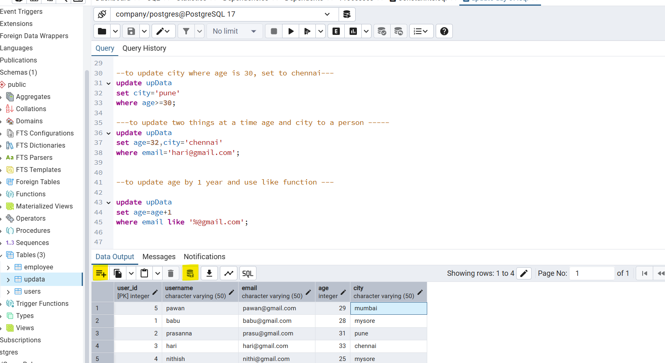

1. we have copy and paste option in this , we can copy any row and then paste it , then save it.  
   If the row has + icon in it that means is has not been saved. Refer highlighted icons.  
     
   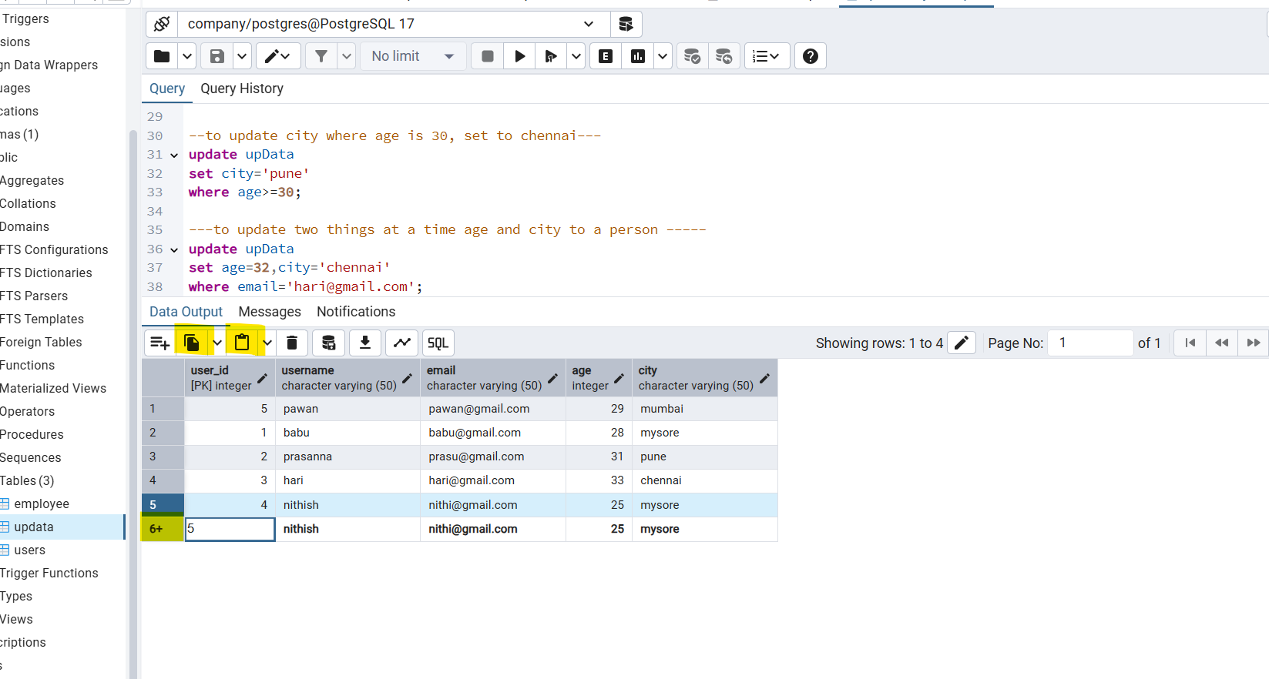

3.to delete the row we have the delete icon to . select the row and then click on delete.  
After delete click on save again.  
  
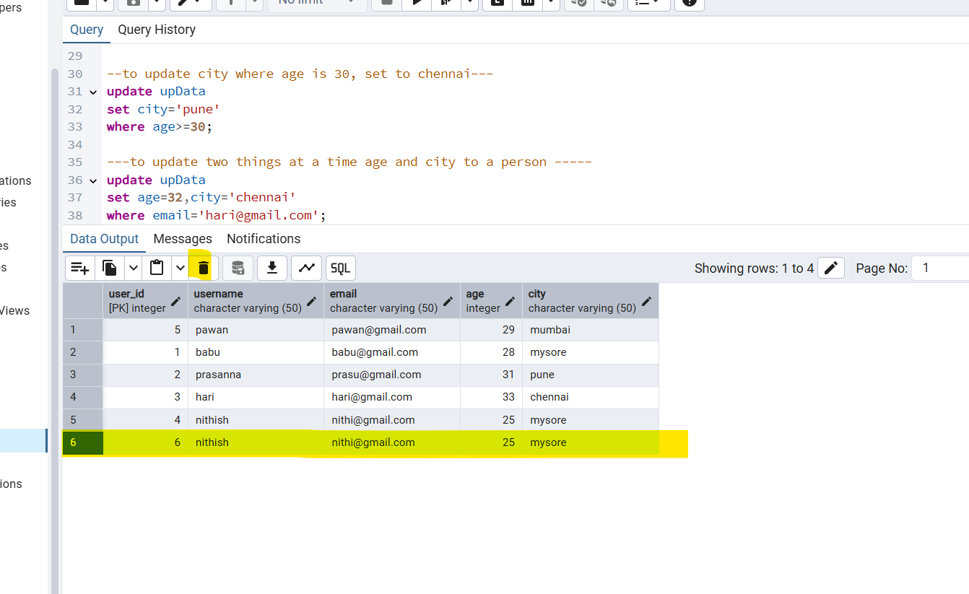

4 we have the option to export our queried data into csv we have to use the download option in toolbar.

We can export it and save it in our local machine.  
  
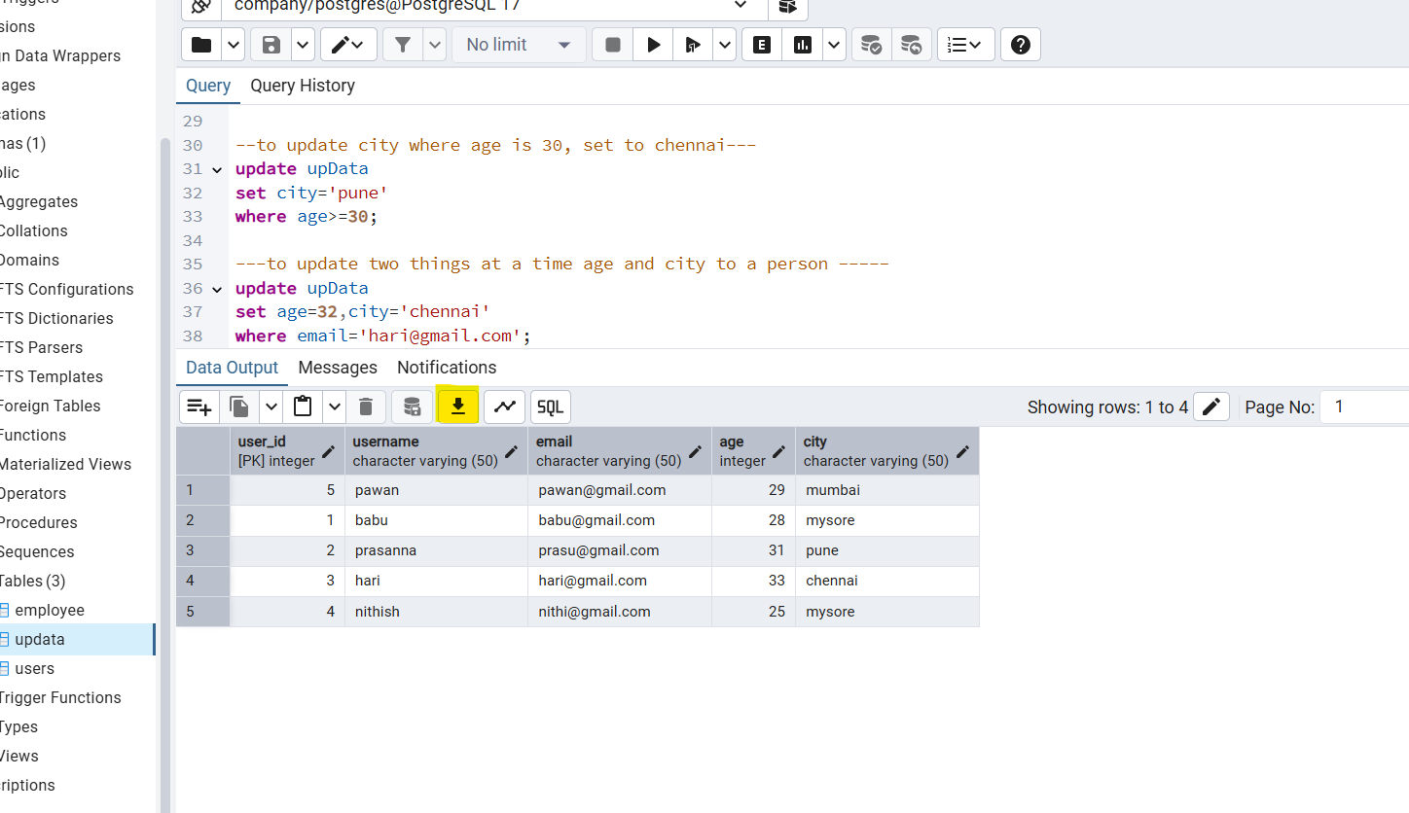

1. We can also generate the graph inside the toolbar option click on the option select the X&Y axis value and click on generate . we can also download that graph.   
     
   